This pattern is also for specific use case
Chain of Responsibility
R1
R3
R2
Client

Here R1, R2, R3 are joined. They have has-a relationship
Client will send some request to object R1, if R1 able to full fill it then it sends the response to client otherwise request goes to next R2 -> R3.
Example-
Suppose there is a ATM. There is multiple handler which handle different notes.

R3 100
20
H2 500
10
H1 1000
5
Client

Suppose client ask for 5000 rupees then request goes o H1 and it has 5 notes of 1000 it will simply return it.
Now if client ask for 6000. Then then H1 will give 5000 rupees and forward the request of remaining 1000 rupees to H2
If client ask for 150 rupees hen we have 2 options either we give 100 and say that this much can be given or you can totally terminate the request, it totally depends on use case
UML Diagram:-
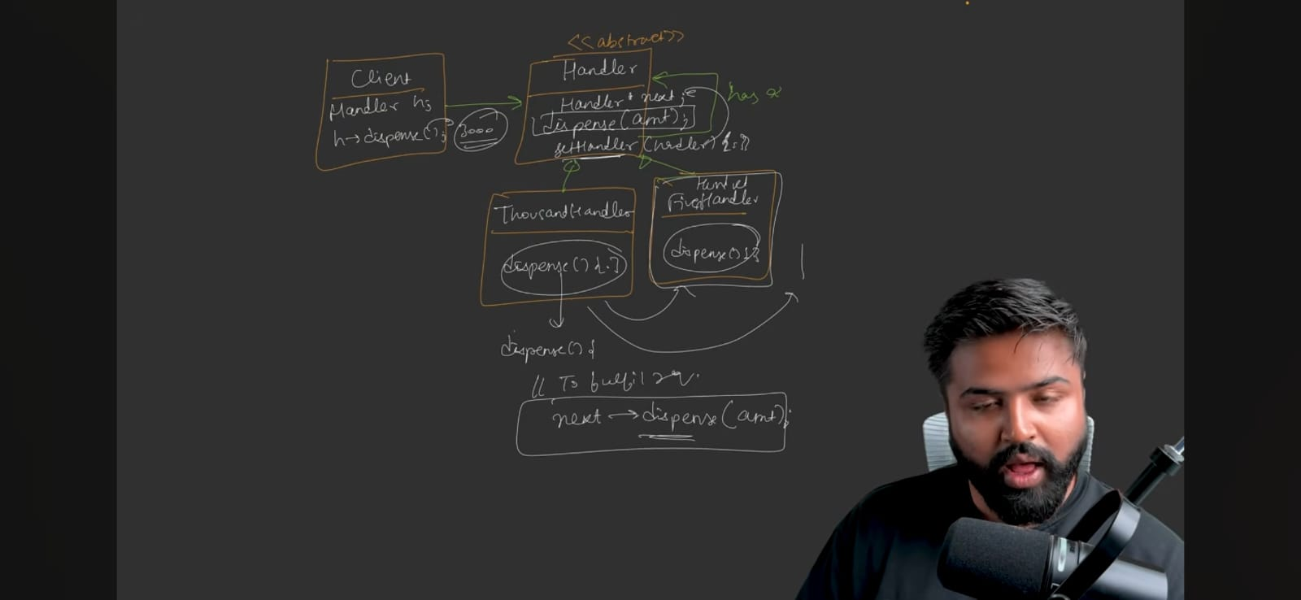

Code….see Notes
Why we did this? What if we did all the logic in the same class?
Because if in future new note comes or some note get demonetize then in that case you to make changes in class. Therefore we are not obeying the OCP Solid principal.
If in future new note comes simply add the new class.
We are also following SRP
Standard UML diagram:-
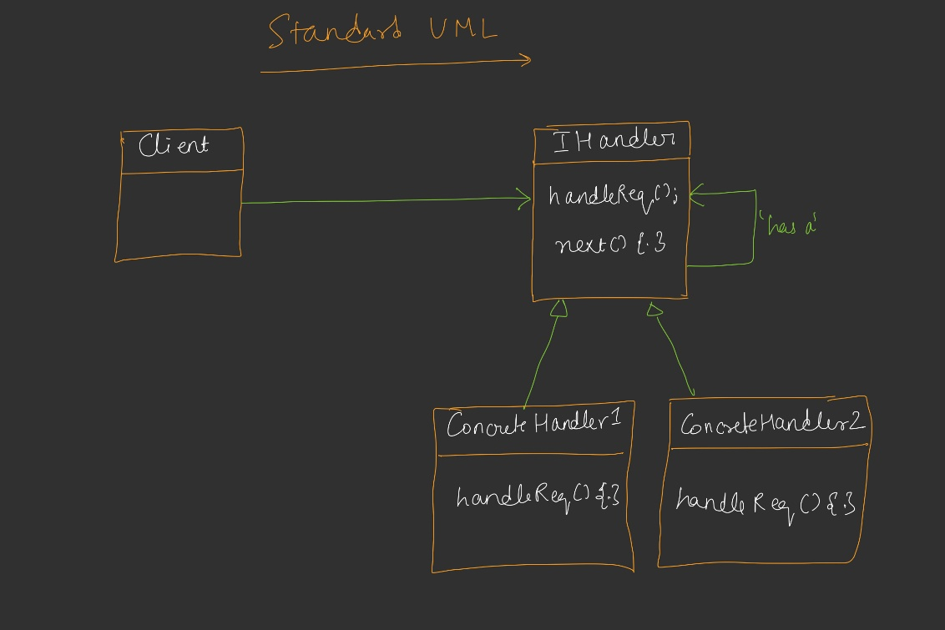
Standard definition
Allow an object to pass a request along a chain of potential handers. Each handler in the chain decides either to process the request or pass it to the next handler.
Note – you can take this design pattern as a linked list
Use cases:-
- Design a Log
There is hierarchy in logs like – INFO -> DEBUG -> ERROR
when client send the log then we can check which log it is
Client
ERROR
DEBUG
INFO
Inteface

- Leave approval system
Suppose the employee sends the request for leave if no of days <2 then TL can approve it if no of days < 4 then it goes to Manager

